**There are 4 print screens, each worth 25%**

1. Turn to page 176 and complete #5 **Restaurant Menu**

Problem Question:

Design:

Output: choose the following below and print screen to #1

**Note**: be sure to write all burgers, fries and drinks.

**#1 Print screen your output below here**

**#2 Copy and paste your code below here**

Public Class Form1

Private Sub Button1_Click(sender As Object, e As EventArgs) Handles Button1.Click

Dim WithCheeseBurger As Double = 4.79

Dim BottledWater As Double = 1.49

Dim total As Double = WithCheeseBurger + BottledWater

If CheckBox1.Checked = True And CheckBox3.Checked = True And RadioButton2.Checked = True _

And RadioButton6.Checked = True Then

TextBox1.Text = FormatCurrency(total)

End If

End Sub

End Class

1. Turn to page 137 and completer #22 (Cost of Bagels)

**#3 Enter (12) & print screen your output below here**

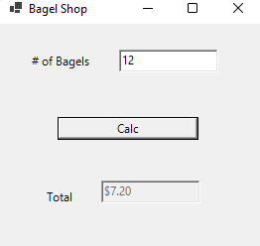

**#4 Copy and paste your code below here**

Public Class Form2

Private Sub Button1_Click(sender As Object, e As EventArgs) Handles Button1.Click

Dim cost As Double

If TextBox1.Text < 6 Then

cost = 0.75 * Val(TextBox1.Text)

ElseIf TextBox1.Text >= 12 Then

cost = 0.6 * Val(TextBox1.Text)

End If

'where formatting occures

TextBox2.Text = FormatCurrency(cost)

End Sub

End Class

**Submit this document to Module 3 Homework #3**